|  |  |  |
| --- | --- | --- |
|  |  | Marketing and Planning  Leadership Council |



Business Plan Template

2445 M Street NW | Washington DC 20037 | P 202.266.5600 | F 202.266.5700 | **advisory.com**

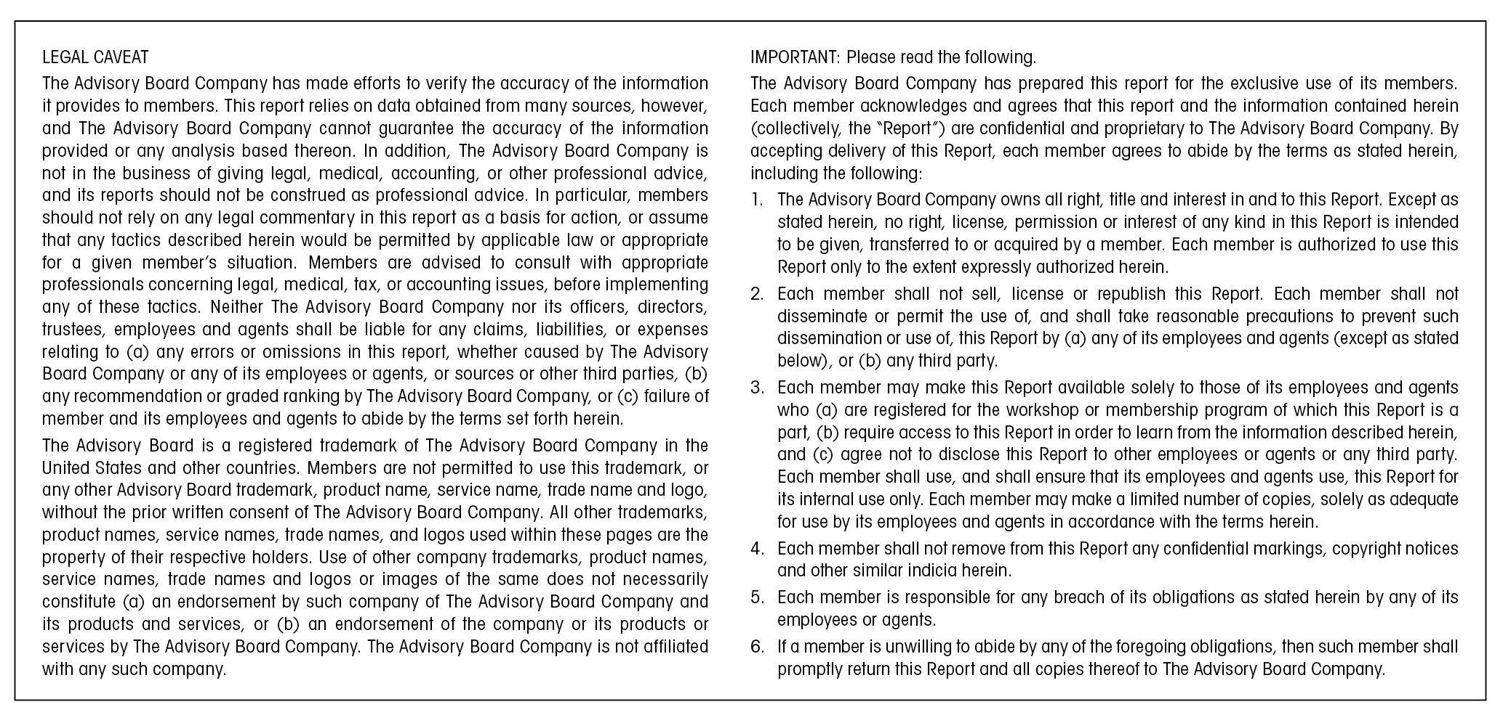

Table of Contents

Business Plan Template 4

I. Executive Summary 5

II. Mission/Strategy Commitment 6

III. Market Analysis 7

IV. Operations Management 12

V. Marketing Plan 16

VI. Financial Analysis 16

VII. Requirements 21

VIII. Feasibility 24

**V. Additional Advisory Board Resources…………………………………………………………………….**

Business Plan Template

***About This Tool***

Once a new business concept receives initial approval, project champions should develop a comprehensive business plan containing well defined metrics, and an in depth analysis of the proposed business endeavor. Every effective business plan should at least incorporate the elements included in the following template to properly evaluate and prepare for implementation. For further information and related practices, please refer to the Marketing and Planning Leadership Council studies Priming the New Product Pipeline, New Business Incubator, and Perfecting Competitive Intelligence.

***Instructions:***

1) Each section of the tool provides a comment and sample box to aid in business plan development. The comment boxes (gray boxes) provide explanations of a particular section, a list of elements that should be included, and links to practices and tools on The Advisory Board Company’s website. The sample boxes provide examples of charts or figures that could be included in addition to explanatory text for each section.

2) Once you have read each of the comment boxes for the section, please insert your own text where each prompt reads Insert Text Here.

3) After inserting your own text, please delete the comment boxes provided by The Advisory Board Company. To finalize your document for internal use, please delete any Advisory Board specific information in the tool such as the title page, instructions, and Terms and Conditions of use.

4) Once all comment boxes have been deleted and you are satisfied with the text of your document please update the Table of Contents page by following the steps below:

a. Right-click on any section of the table of contents

b. Select “Update Field”

c. Select “Update Page Numbers Only” (This is a critical step; if you select “Update Entire Table” it will alter the format of the table, and cannot be undone).

***Contact Us***

For questions or comments about this document, please call or email:

Alicia Daugherty

Practice Manager

Marketing and Planning Leadership Council

(202) 266-5600

[daughera@advisory.com](mailto:daughera@advisory.com)

1. Executive Summary

Effective executive summaries should “sell” the proposed idea by providing a concise (less than two pages) assessment of key plan components, including:

• Market opportunity  
• Program/management characteristics that predict short- and long-term success  
• Ability to overcome expected implementation challenges  
• Capital required to start and maintain the program/service  
• Anticipated financial return and other advantages

* 1. ***Service/Program Description***

*Please Insert Text Here*

* 1. ***Plan Summary***

*Please Insert Text Here*

1. Mission/Strategy Commitment

This section should describe how the program or service advances the institution’s mission and strategic goals. Plans should clearly align with the institution’s strategic objectives.

* 1. ***Mission Implications***

*Please Insert Text Here*

* 1. ***Strategy Implications***

*Please Insert Text Here*

1. Market Analysis

The first projection made when developing a business plan is an analysis of potential market volume. Volume forecasting estimates the total market size and the hospital’s likely share, given its position within the competitive landscape. Such market analyses include quantitative assessment (e.g., demographics, utilization rates), as well as qualitative assessment (e.g., competitor offerings, clinical or technological advances that may affect demand); tools for each of these components are described in further detail below. For non-clinical businesses, please include the necessary market data to assess the market size, potential competitors, and volume forecasts.

To assist in market sizing and projecting volumes, members of the Marketing and Planning Leadership Council may use the Inpatient and Outpatient Estimator Tools to project local demand for associated procedures and service lines. Similarly, The Primary Care Volume Estimator generates visit volume estimates for primary care services. Additionally, members may consult the Service Line Forecast Compendium, updated with 2012 procedure volume data, for an overview of national trends, drivers, and barriers for specific procedures and service lines. These resources can be used to compliment market demand data generated with the volume forecasting tool (section b).

TOOL: [Inpatient Market Estimator](http://www.advisory.com/Research/Health-Care-Advisory-Board/Tools/2010/Inpatient-Market-Estimator)

TOOL: [Outpatient Market Estimator](http://www.advisory.com/Research/Health-Care-Advisory-Board/Tools/2010/Outpatient-Market-Estimator)

TOOL: [Primary Care Volume Estimator](http://www.advisory.com/Research/Marketing-and-Planning-Leadership-Council/Tools/2011/Primary-Care-Volume-Estimator)

TOOL: [Service Line Forecast Compendium](http://www.advisory.com/Research/Marketing-and-Planning-Leadership-Council/Studies/2011/Service-Line-Forecast-Compendium)

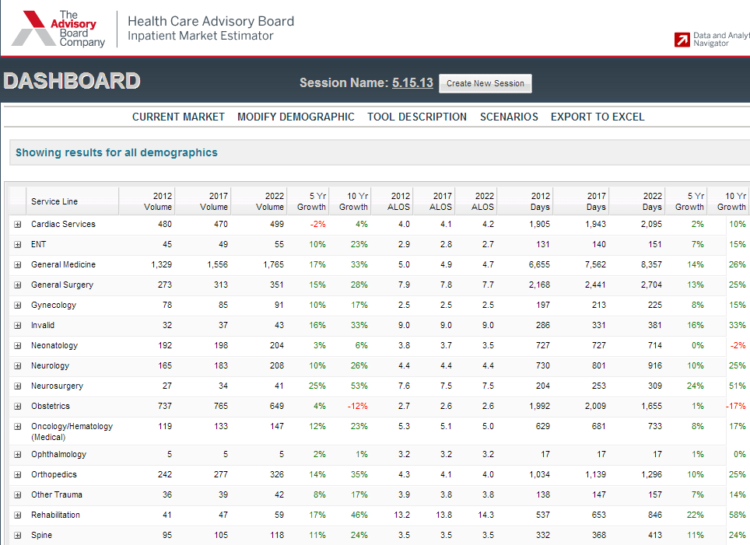

1. ***Target Population***

Business plans should not only identify the intended customers/patients of the proposed service, but also describe their clinical and service needs as well as relevant consumer preferences.

*Please Insert Text Here*

1. ***Market Sizing***

Demand analyses outline demand within a specified market area or geography. These analyses include quantitative assessment (e.g., demographics, utilization rates), and qualitative assessment components (e.g., competitor offerings, clinical or technological advances that may affect demand).

Inaccurate, demand projections result in flawed financial forecasts and incorrect operating assumptions. Unrealistic projections can lead products to fail to meet the expectations laid out in the business plan.

Demand analyses include several factors, such as utilization patterns, market share trends, payer channeling, physician and consumer preferences, and advances in care.

The following tool provides formulas for preliminary demand forecasting, which gives a rough estimate of potential volumes, as well as methods for adjusting forecasts by four major external factors: consumer influence, physician influence, impact of clinical innovation, and impact of competitive position.

TOOL: [Volume Forecasting](http://www.advisory.com/research/marketing-and-planning-leadership-council/tools/2014/business-innovation-toolkit/volume-forecasting-worksheet)

*Please Insert Text Here*

1. ***Competitive*** ***Factors***

Demonstrating that the combination of service characteristics and operational strengths will be positively received by the market reveals a new service or program’s potential for success.

The tools below assist in assessing an institution’s competitive environment.

The first is an audit to assess strength of service line components in terms of market share, technological capabilities and patient retention.

The second profiles two methods of mapping patient origin, referral patterns, competition and demographic trends to clarify geographic threats and opportunities.

TOOL: [Performance Gap Analysis](http://www.advisory.com/sitecore%20modules/web/~/media/Advisory-com/Research/MPLC/Tools/2010/Business-Planning-Toolkit/Performance-Gap-Analysis.pdf)

TOOL: [Geographic Opportunity Mapping](http://www.advisory.com/sitecore%20modules/web/~/media/Advisory-com/Research/MPLC/Tools/2010/Business-Planning-Toolkit/Geographic-Opportunity-Mapping.pdf)

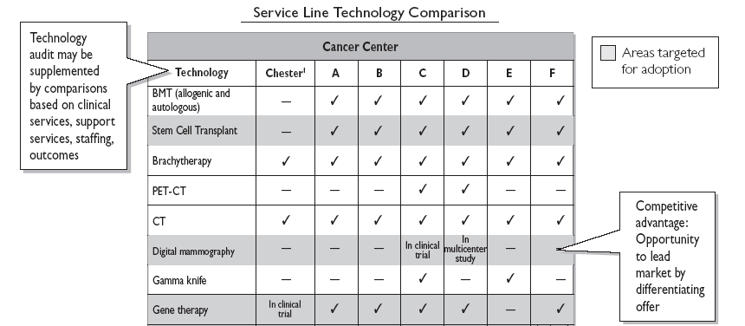

*Please Insert Text Here*

1. ***Projected Volumes***

After assessing demand within the market area and the competitive environment, the institution should evaluate volume projections.

As in the market sizing section above, such volume projection analyses include quantitative assessment (e.g., demographics, utilization rates), as well as qualitative assessment (e.g., competitor offerings, clinical or technological advances that may affect demand).

The following tool utilized in the market sizing section can also be utilized when evaluating institution specific demand. The tool provides formulas for preliminary demand forecasting, which gives a rough estimate of potential volume to be captured by the institution, as well as methods for adjusting forecasts by four major external factors: consumer influence, physician influence, impact of clinical innovation, and impact of competitive position.

TOOL: [Volume Forecasting](http://www.advisory.com/research/marketing-and-planning-leadership-council/tools/2014/business-innovation-toolkit/volume-forecasting-worksheet)

*Please Insert Text Here*

1. Operations Management

This section of the business plan should provide an operational snapshot of the business and discuss its potential impact on clinical and service quality. Issues to consider are:

• Location and space requirements (for product development, production and delivery as relevant)

• Management structure and reporting relationships

• Staffing (medical and administrative)

• Equipment (medical and administrative)

* 1. ***Location***

*Please Insert Text Here*

* 1. ***Space***

*Please Insert Text Here*

* 1. ***Management Structure***

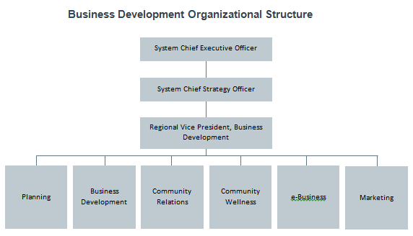

*Please Insert Text Here*

* 1. ***Staffing***

|  |  |  |  |  |
| --- | --- | --- | --- | --- |
|  | Current Workforce | | Total New Hire Need | |
| Group/Sub-Group | Headcount | FTEs | Headcount | FTEs |
| Oncologist | - | - | - | - |
| Medical Assistant | - | - | - | - |
| RN | - | - | - | - |

*Please Insert Text Here*

* 1. ***Equipment***

*Please Insert Text Here*

* 1. ***Clinical Quality***

*Please Insert Text Here*

* 1. ***Service Quality***

*Please Insert Text Here*

1. Marketing Plan

Program champions should solicit ideas and input from marketing staff during the plan development process to outline likely market response upon plan implementation develop the marketing campaign. The Communications Checklist provides common concerns among stakeholders, and communications strategies to address stakeholder interests.  
  
Business plans should describe how the program or service impacts or extends the existing institutional brand, as well as propose appropriate promotional strategies for:

* Targeted consumer campaigns
* Physician-directed marketing (when appropriate)
* Internal awareness-building efforts
* External awareness-building efforts

TOOL: [Precision Marketing Toolkit](http://www.advisory.com/Research/Marketing-and-Planning-Leadership-Council/Tools/2009/Precision-Marketing-Toolkit)

TOOL: [Marketing Plan Template](http://www.advisory.com/~/media/Advisory-com/Research/MPLC/Tools/2010/Marketing-function-toolkit/Marketing-Plan-Template.pdf)

1. ***Marketing Strategy***

*Please Insert Text Here*

1. ***Brand Impact***

*Please Insert Text Here*

1. Financial Analysis

Complete financial analysis involves projecting capital requirements and creating a five-year pro forma or detailed cash flow statement.

Pro forma results feed into the net present value (NPV) calculation to yield an assessment of the true economic value of the proposal. The NPV calculation incorporates the factors affecting economic return to provide a single, comprehensive metric for gauging a venture’s financial worthiness.

While organizations may correctly account for expected capital and operating costs when developing a business plan, and have a reliable methodology for projecting revenues, they may neglect to take into account opportunity cost and risk, both of which greatly influence economic return.

By neglecting to incorporate these variables, a new product may appear more (or less) attractive than its true worth. Failing to consider opportunity cost and risk proves especially costly when investment opportunities far exceed available venture funding.

The Financial Forecasting tool provides templates for documenting start-up expenses, a pro forma template and assumptions, and a risk-adjusted NPV worksheet.

The Marketing and Planning Leadership Council also has interactive, customizable pro forma Excel spreadsheets for a variety of products, including bariatrics, spine, stroke, sleep, and continence centers. –This is what you will use to make a general Pro Forma in Excel.

TOOL: [Financial Forecasting](http://www.advisory.com/~/media/Advisory-com/Research/MPLC/Tools/2010/Business-Planning-Toolkit/Financial-Forecasting.pdf)

TOOL: [Product-Level Pro Forma Spreadsheets](http://www.advisory.com/Research/Marketing-and-Planning-Leadership-Council/Tools/2007/Product-Level-Pro-Forma-Spreadsheets)

* 1. ***Start-Up Capital***

*Please Insert Text Here*

* 1. ***Operating Costs***

*Please Insert Text Here*

* 1. ***Payer Type, Payer Mix (if relevant)***

*Please Insert Text Here*

* 1. ***Cash Flow***

*Please Insert Text Here*

* 1. ***Net Present Value (NPV)***

Sample Pro Forma

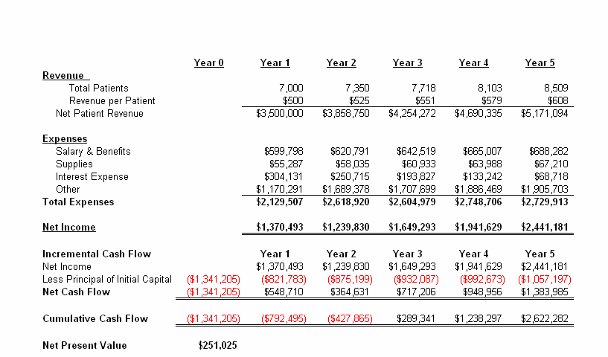

*Please Insert Text Here*

* 1. ***Conservative/Moderate/Aggressive Scenarios***

*Please Insert Text Here*

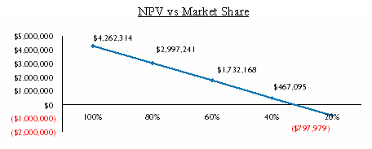

* 1. ***Payback Period***

*Please Insert Text Here*

1. Requirements

While most of the business plan describes the operations of the business, it should also identify the elements required to initially launch the program. These requirements may include:

• Launch/Implementation Timeline and Key Steps

• Facility Requirements

• Information Systems Requirements

• Medical Staff Requirements

* Staff Requirements

• Payer Contracting Activities

• Regulatory Hurdles (for example, CON requirements)

* Marketing Requirements
* Patients or Other Legal Requirements
* Partnership Requirements

1. ***Launch/Implementation Timeline***

*Please Insert Text Here*

1. ***Facility*** ***Requirements***

*Please Insert Text Here*

1. ***Information Systems*** ***Requirements***

*Please Insert Text Here*

1. ***Medical Staff*** ***Requirements***

*Please Insert Text Here*

1. ***Staff Requirements***

*Please Insert Text Here*

1. ***Payer*** ***Contracting Activities***

*Please Insert Text Here*

1. ***Regulatory Hurdles***

*Please Insert Text Here*

1. Feasibility

This section of the business plan should assess the potential business’ feasibility by explaining the degree of risk associated with the investment and evaluating barriers to implementation.

The analysis takes the business plan beyond spreadsheets to examine resource constraints, technical limitations, and government regulations that may impact a new product launch.

By isolating and evaluating each operating requirement, a thorough feasibility analysis “pressure tests” all business plan expectations to assess the probability of achieving overall performance targets.

The following tool assists business plan authors with identifying potential barriers and possible solutions for inclusion in the plan prior to submission.

TOOL: [Feasibility Analysis Worksheet](http://www.advisory.com/Research/Marketing-and-Planning-Leadership-Council/Tools/2014/Business-Innovation-Toolkit/Feasibility-Analysis-Worksheet)

1. ***Risk Assessment***

*Please Insert Text Here*

1. ***Launch/Implementation Difficulty***

*Please Insert Text Here*